Algebra 3-4 Name: ____________________

Chapter 4 Re-Test Block: ________

For problems 1 – 3, simplify the expression.

1. 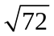 2. 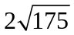

3. 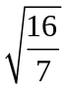

For problems 4 – 6, factor the expressions completely.

4. x² + 9x + 14 5. 64y² – 9

6. 3x² + 12x – 15

For problems 7 – 8, solve for x by factoring.

7. x² – 14x + 49 = 0 8. 2x² + 7x + 3 = 0

x = __________ x = __________

For problem 9, solve for x by finding the square root.

9. (x + 2)² + 5 = 17

x = __________

For problems 10 – 11, solve for x by completing the square.

10. x² – 4x + 9 = 0 11. 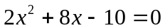

x = __________ x = __________

For problems 12 – 15, write the expression as a complex number in standard form.

12. 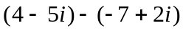 13. 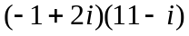

14. 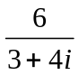 15. -4i(9 + 8i)

For problem 16, solve for x by using the Quadratic Formula.

16. x² – 3x + 5 = 0

x = __________

For problem 17, solve the quadratic equation by using the best method.

17. 4x² + 2x – 5 = 0

x = __________

For problems 18 – 19, choose the correct solutions for each quadratic equation.

18. x² = -16
A. x = 4

B. x = 4

C. x = 4i

D. x = 4i

19. 8r² + 7 = 5r² + 4
A. x = i

B. x = i

C. x = 1

D. x = 1

For problems 20 – 22, answer the question.

20. Find the values of x, knowing the area of the rectangle is 51 ft².
x = __________

x

x + 14

21. From 1990 to 1993, the number if truck registrations (in millions) in the United States can be approximated by the model R = 0.29t² + 45 where t is the number of years since 1990. During which year were approximately 46.16 million trucks registered?

22. How do we find the discriminate? What does the discriminate tell us? Describe each case.

